- Go to BTP cockpit Connectivity Destination create.
Create the destination by providing all the above information’s.

For password:
Open: https://myaccount.google.com/apppaswords
Generate an app password: hulmwpjixmvnpqpo
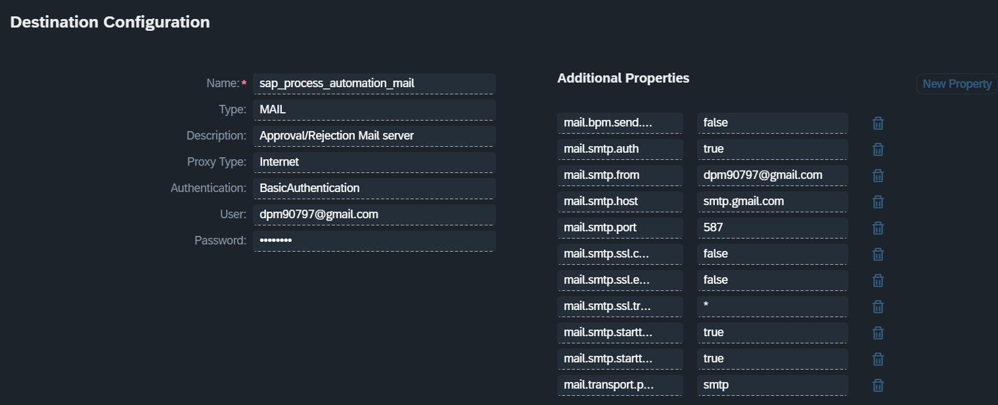
#Fri Jul 25 17:09:22 GMT 2025
mail.smtp.ssl.trust=*
mail.smtp.port=587
mail.password=<removed>
mail.bpm.send.disabled=false
mail.user=dpm90797@gmail.com
mail.smtp.auth=true
mail.smtp.starttls.enable=true
mail.smtp.from=dm90797@gmail.com
mail.smtp.host=smtp.gmail.com
Name=sap_process_automation_mail
mail.smtp.ssl.enable=false
Type=MAIL
mail.smtp.ssl.checkserveridentity=false
mail.transport.protocol=smtp
Authentication=BasicAuthentication
mail.smtp.starttls.required=true
mail.description=Approval/Rejection Mail server
ProxyType=Internet

Which can be referenced through.
https://help.sap.com/docs/build-process-automation/sap-build-process-automation/configuring-smtp-mail-destination

- Go to SAP Build Control Tower Mail Server
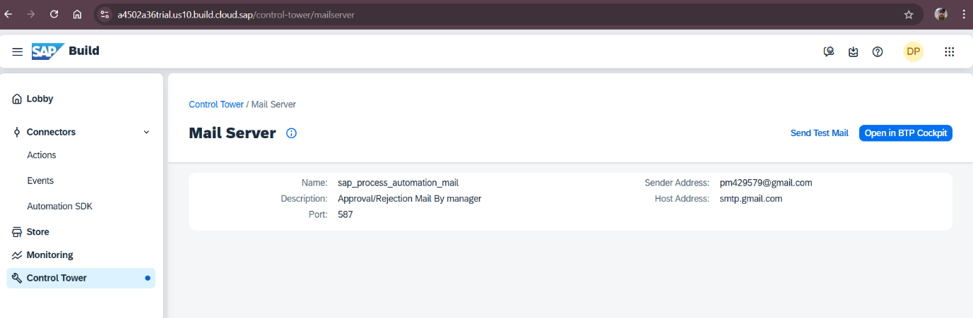
it will automatically connect it to the destination created in the BTP cockpit.

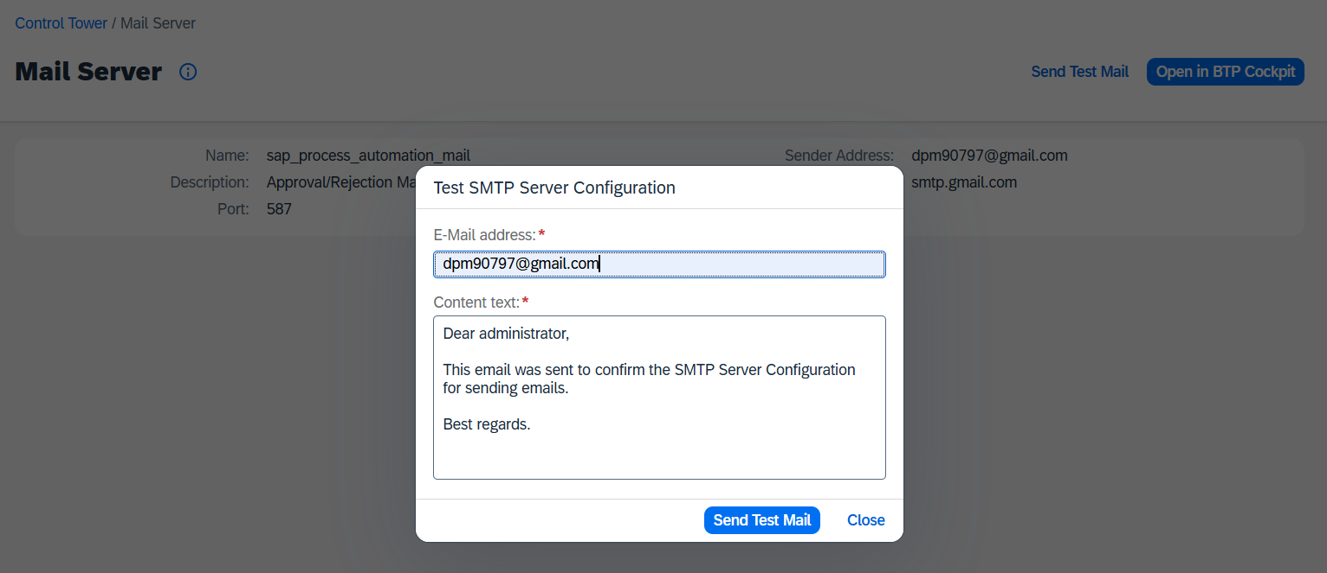

Check your mail you should get an email like below.
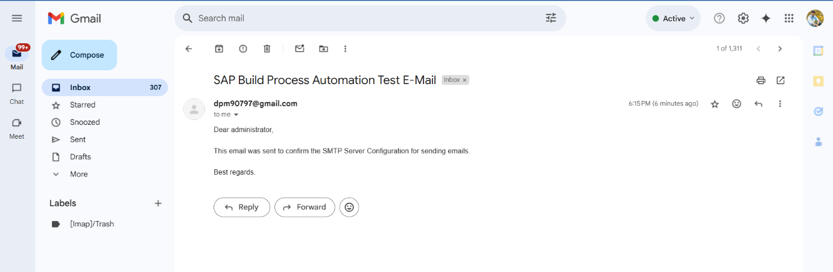

COMPLETED You have successfully configured the Email in you SAP BTP for Build Process Automation

